War of the universe



NIM : a11.2018.11162

Nama: Ali Zaenal Abidi

Kelompok:4501

Catalog

**Tentang Game 3**

**perang pesawat ruang angkasa 3**

**I. Screenshot 3**

**Detail pengembangan aplikasi 4**

**I. Flowchart 4**

**II. Screenshot lengkap 4**

**Refrensi 6**

Tentang Game

I . Diskripsi

perang pesawat ruang angkasa

1. Screenshot

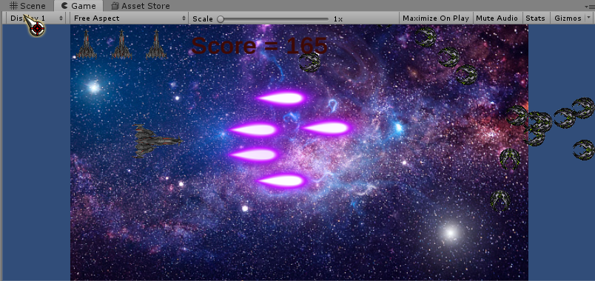

Detail pengembangan aplikasi

1. Flowchart

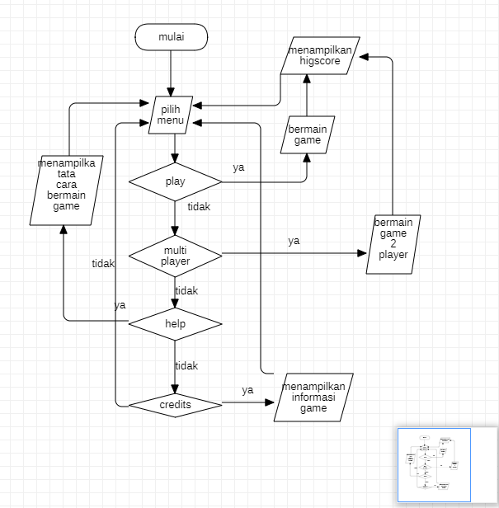

1. Screenshot lengkap

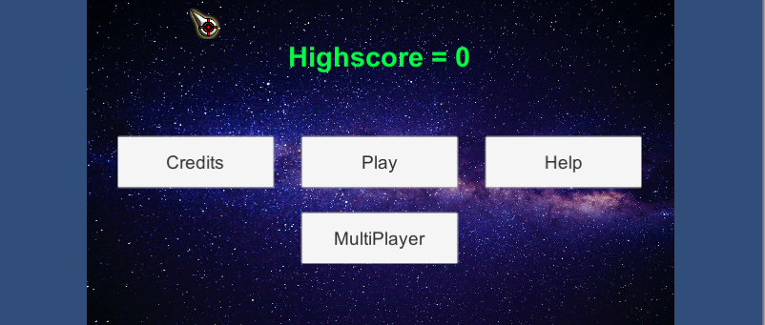

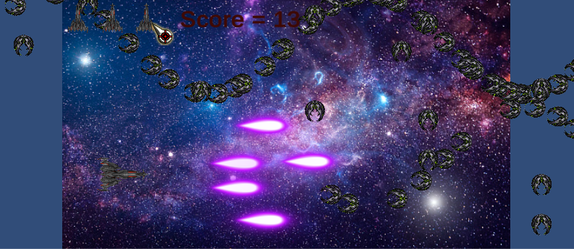

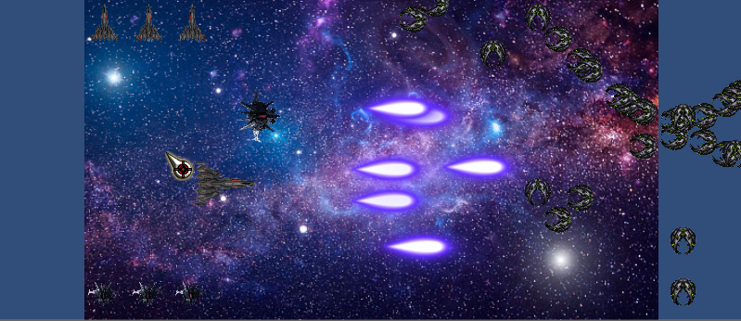

Refrensi

refrensi link :

#ASSETS#

bullet :https://pngimage.net/bullet-sprite-png-1/ & https://wenrexa.itch.io/laser2020?download

Player :https://www.pngegg.com/en/search?q=dax+Daily+Hedged+Nr+Gbp

backgroud : https://unsplash.com/s/photos/universe

enemy : https://www.pngegg.com/en/png-bltqk

Tutorial :

https://www.youtube.com/watch?v=u8tot-X_RBI : object movement

https://www.youtube.com/watch?v=MnP7NzAoFqM&t=319s : fire lasser

https://www.youtube.com/watch?v=YtRxkWoTl_o :enemy movement

https://www.youtube.com/watch?v=Ay159WsGDJQ : life system

beberapa script flappy bird